Contact person |  | Phone
Group | KYIV INTERNATIONAL CONTRACT FAIR, LTD  2015-2016 Kiev, Ukraine
E-mail

Guest Name | Arrival | Departure | No. of Nights | No. of Rooms | No of Pax

SPECIAL ACCOMMODATION RATES
Please choose the type of room, single/double occupancy by checking relevant box with X or other sign
Room category | Single occupancy | Double occupancy
Standard room (22 sq.m.)  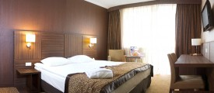 | ❐ 80 EUR | ❐ 90 EUR  Double / Twin
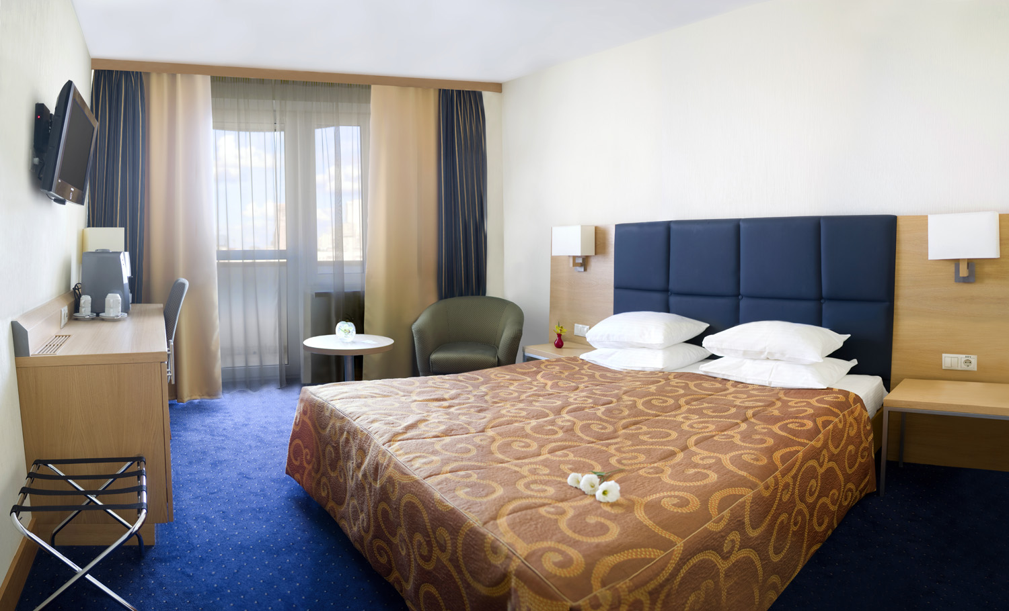 | ❐ 138 EUR | ❐ 154 EUR  Double / Twin
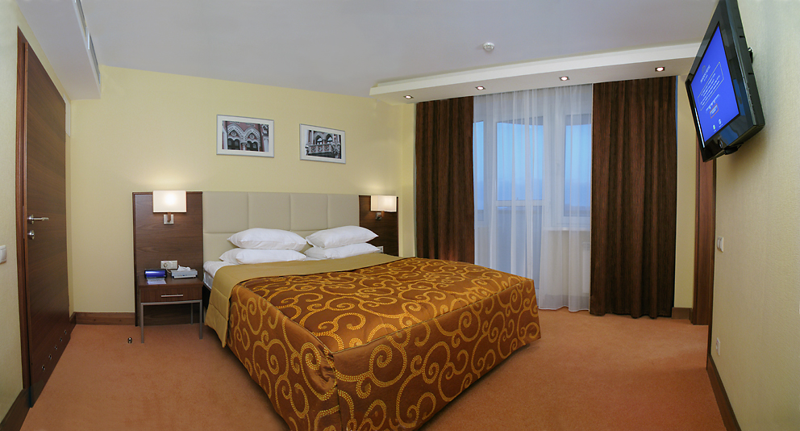 | ❐ 160 EUR | ❐ 176 EUR  Double / Twin
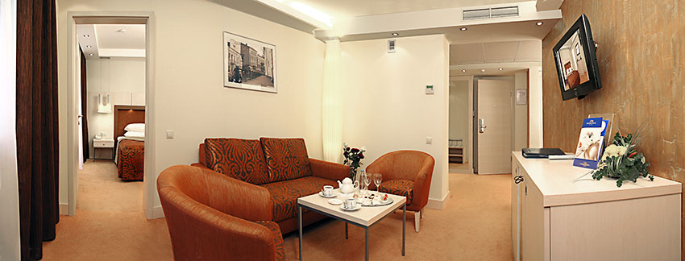 | ❐ 187 EUR | ❐ 203 EUR  Double / Twin
Rates
- All rates include VAT
- All rates are per room and night including buffet Breakfast
- Payments are made in local currency by the rate set by the National Bank of Ukraine for the foreign currencies
- According to Kyiv Municipal Board enactment №573/5385 of 30.12.2010 (Addition 14) Tourist Tax has been implemented at rate of 1% accommodation cost. This travel extra charge is not applicable to meals and additional services.

- Reservation and Cancellation Policy: Guaranteed Reservation (credit card and signature are mandatory):
After receiving the credit card details and the signed booking form the room will be blocked for you for the entire night, regardless of your time of arrival. In case of No-Show, one night will be charged for each room booked.
Please note there’s limited amount of rooms available under special rates.
Changes and cancellations of guaranteed bookings must be made until 24 hours prior to 12-00 of arrival date.
The hotel reserves the right to amend the conditions accordingly after expiration of the quoted deadline.

Credit Card Details to guarantee booking:
I, the undersigned, authorize The President Hotel Kiev, Ukraine, to charge the credit card below in case of No-Show or Cancellation.

Card holder name: __________________________________________________________

Card No. ___________________________________Exp:________ Signature:___________________

Confirmed by The President Hotel Kiev, Ukraine:_______________________
Date: ___________ Confirmation N:_______________

